Exercise 1
num1=[0 0 10];
den1=[1 2 10];
num2=[0 0 5];
den2=[0 1 5];
[numA,denA]=series(num1,den1,num2,den2);
[numB,denB]=parallel(num1,den1,num2,den2);
[numC,denC]=feedback(num1,den1,num2,den2);
[numD,denD]=cloop(num1,den1,-1);
sysA=tf(numA,denA)
sysB=tf(numB,denB)
sysC=tf(numC,denC)
sysD=tf(numD,denD)

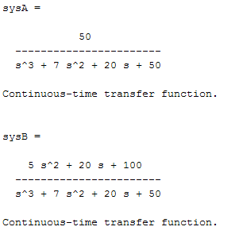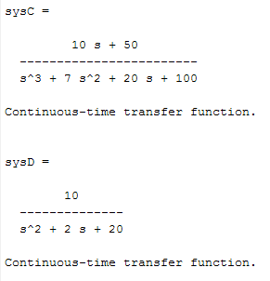
Exercise 2
num1=[0 0 4];
den1=[0 0 1];
num2=[0 0 1];
den2=[0 1 2];
[num,den]=series(num1,den1,num2,den2);
num3=[0 5 0];
den3=[0 0 1];
[numa,denum]=feedback(num,den,num3,den3);
sys=tf(numa,denum)

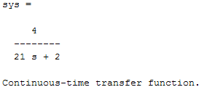

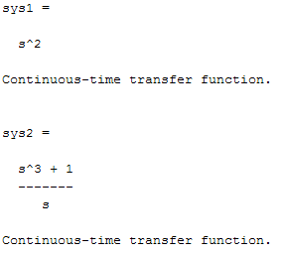
Exercise 3
num1=[0 1 0];
den1=[0 0 1];
num2=[0 1 0];
den2=[0 0 1];
[num3,den3]=series(num1,den1,num2,den2);
sys1=tf(num3,den3)
num4=[0 0 1];
den4=[0 1 0];
[num5,den5]=parallel(num3,den3,num4,den4);
sys2=tf(num5,den5)
[num6,den6]=cloop(num5,den5,-1);
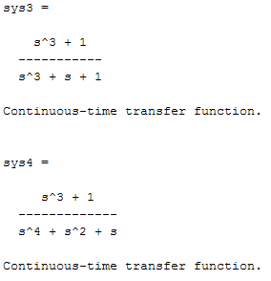
sys3=tf(num6,den6)
num7=[0 0 1];
den7=[0 1 0];
[num8,den8]=series(num6,den6,num7,den7);
sys4=tf(num8,den8)
num9=[0 1 0];
den9=[0 0 1];
[num,den]=feedback(num8,den8,num9,den9);
sys=tf(num,den)

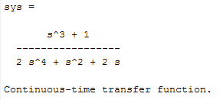

Exercise 4

(b)
num=[1 7 2];
den=[1 9 26 24];
[A,B,C,D]=tf2ss(num,den)
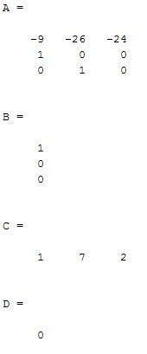

(a)
num=[0 1 0];
den=[1 14 56 160];
[A,B,C,D]=tf2ss(num,den)
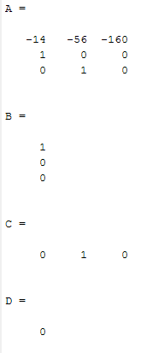

Exercise 5

(a)
A=[0 1;-6 -5];
B=[0;1];
C=[8 1];
D=[0];
[num,den]=ss2tf(A,B,C,D)
sys=tf(num,den)
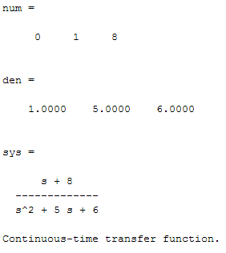
(b)
A=[0 1 0;0 0 1;-1 -2 -3];
B=[10;0;0];
C=[1 0 0];
D=[0];
[num,den]=ss2tf(A,B,C,D)
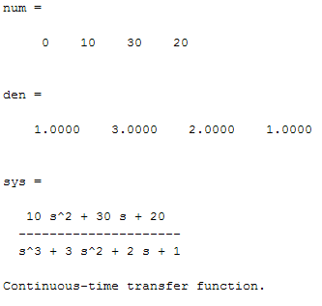
sys=tf(num,den)

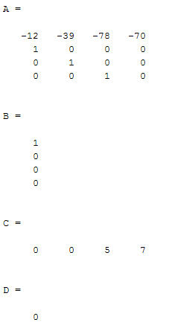
Exercise 6
num1=[0 5 7];
den1=[0 1 7];
num2=[0 0 1];
den2=[1 5 4 0];
[num3,den3]=series(num1,den1,num2,den2);
sys1=tf(num3,den3)
num4=[0 0 10];
den4=[0 0 1];
[num,den]=feedback(num3,den3,num4,den4);
sys=tf(num,den)
[A,B,C,D]=tf2ss(num,den)
